GLOBAL WEBSITE ---- REVIEWS

-  -----
Missing the Slogan
- 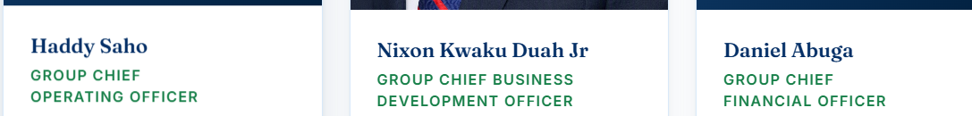
The Title --- Global Chief ………. Not Group Chief ……… please change this in all our profile write up as well
Also, I am based in Washington State or make it United State.

- Leadership ----- Please use the exact write up I sent to you because it came from the people themselves. That is how they want it to be.

- 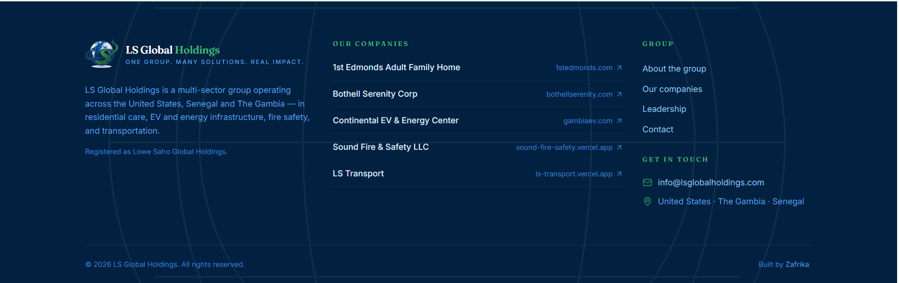

This section is too dark for me … can you brightening it. I know you are matching the 2-way colors but still know that you can do something about it. --- But let the professional thing ruin lol if I am not making sense.

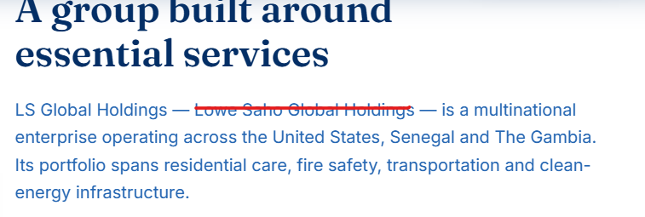
- Take the cancelled – they do not want the name to show up.

- 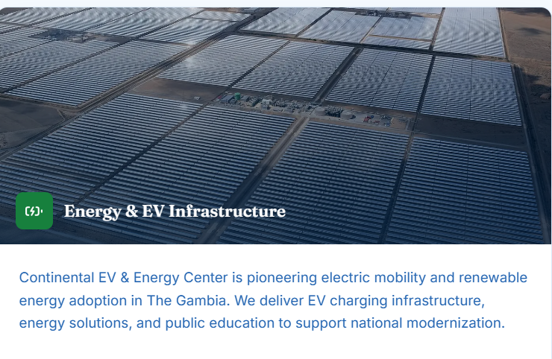

Make this focus more on Electric Cars and charging hub---- change this picture and get us Ev and charging hub

- 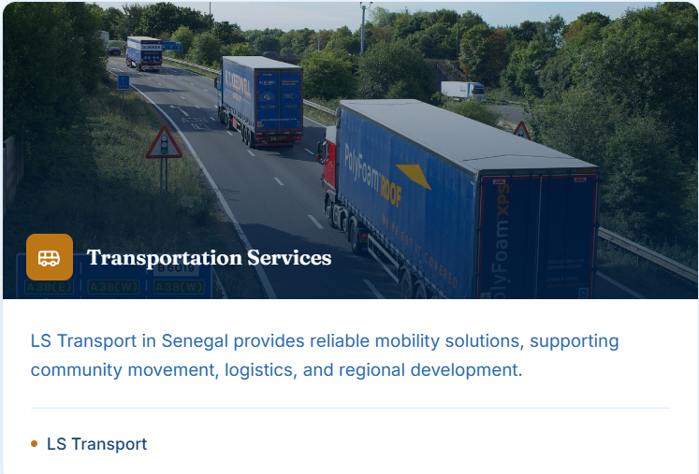
Add a Bus picture to this too…. We are into such than this.

- 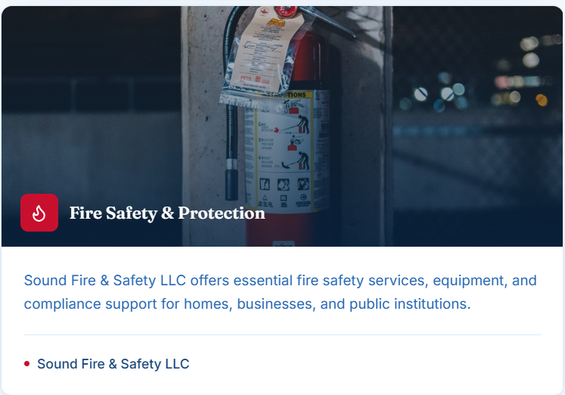
Can we get a brighter picture ---- if possible to all the pictures.

- 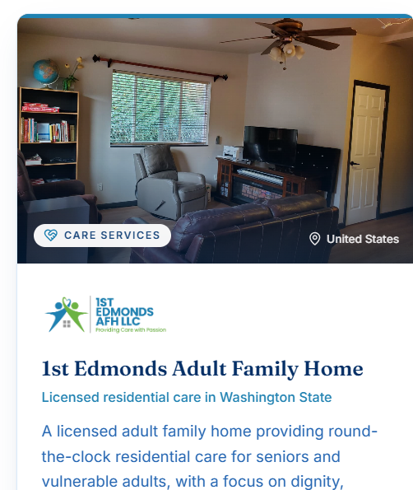
Please change this picture and use the front view you edited.

- 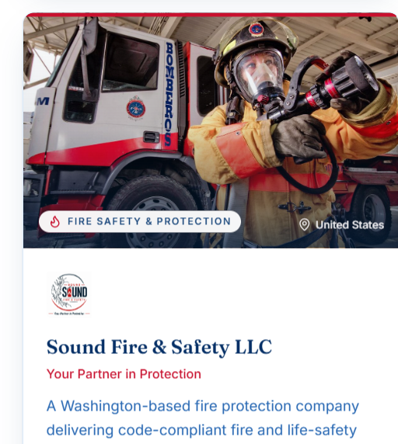
Use Variety of Fire extinguisher pictures instead of this.

Focus must be on the vehicles more –pls change this picture
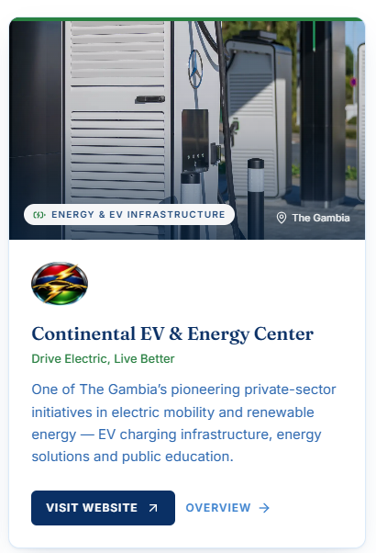
Focus must be on the vehicles more –pls change this picture

- 
Please change this gentle to a professional picture.

- 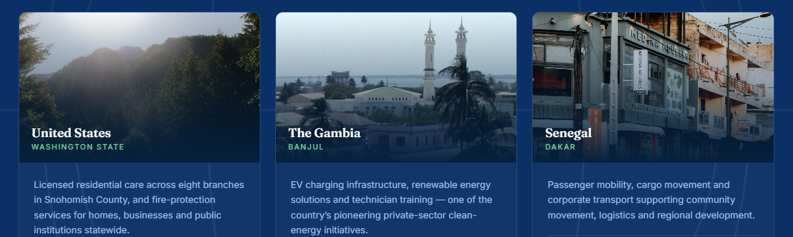
Please get a corporate building pictures for all

- 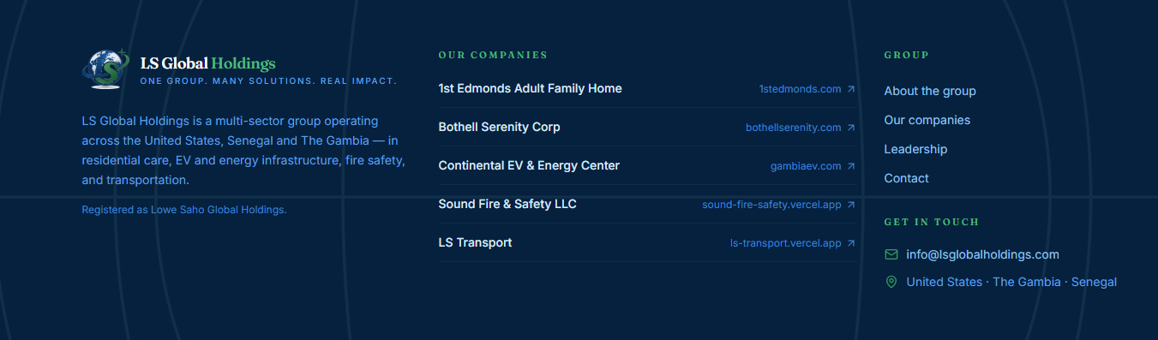
Logo – missing ----SLOGAN ---
Registered as LS Global Holdings NOT – Lowe Saho Global Holdings

Continental Ev ------- can it say continentalev.com INSTEAD of gambiaev.com

GET IN TOUCH
CONTACT --- 425-350-2217 /425-346-9231 / 325-703-0636

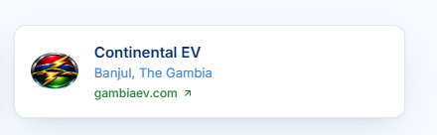
Why not using --- continentalev.com

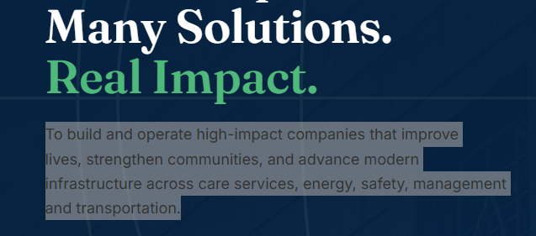
We develop and manage high‑impact businesses that strengthen communities, elevate quality of life, and advance modern infrastructure across care services, energy, safety, management, and transportation.

